HOMEWORK 3

JERIN JOY
C0755173

Q1.
Try running the pthreads_0 program on your Beaglebone

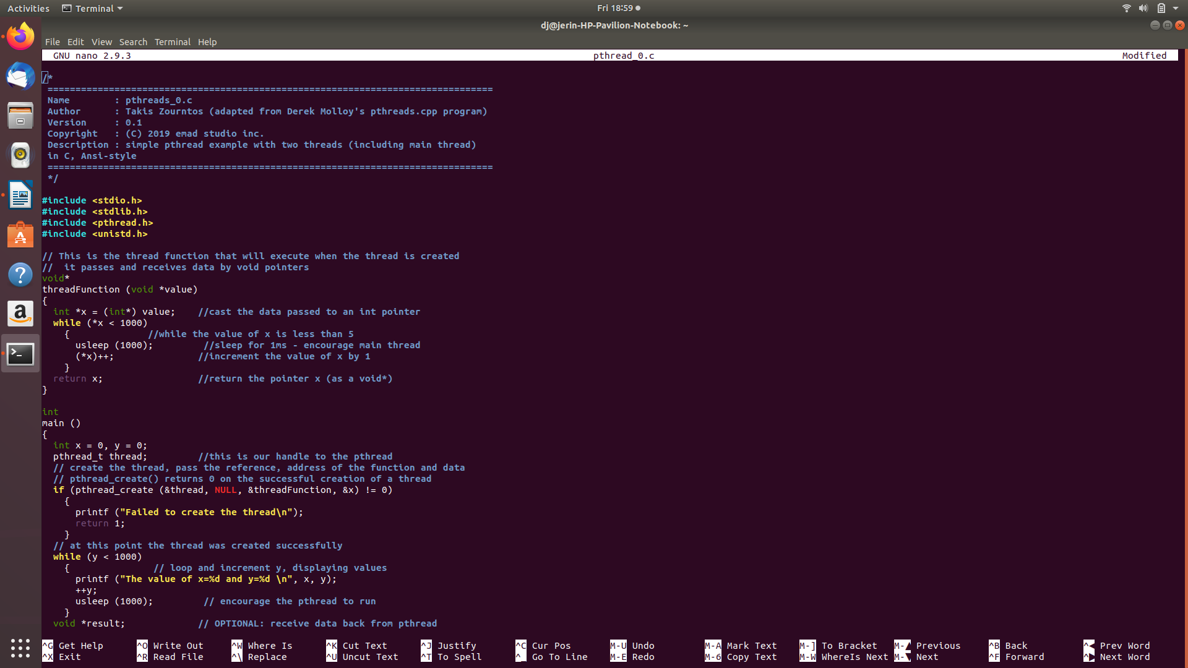

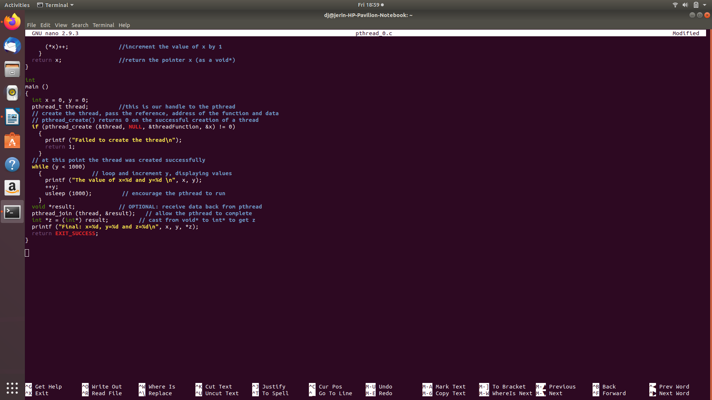

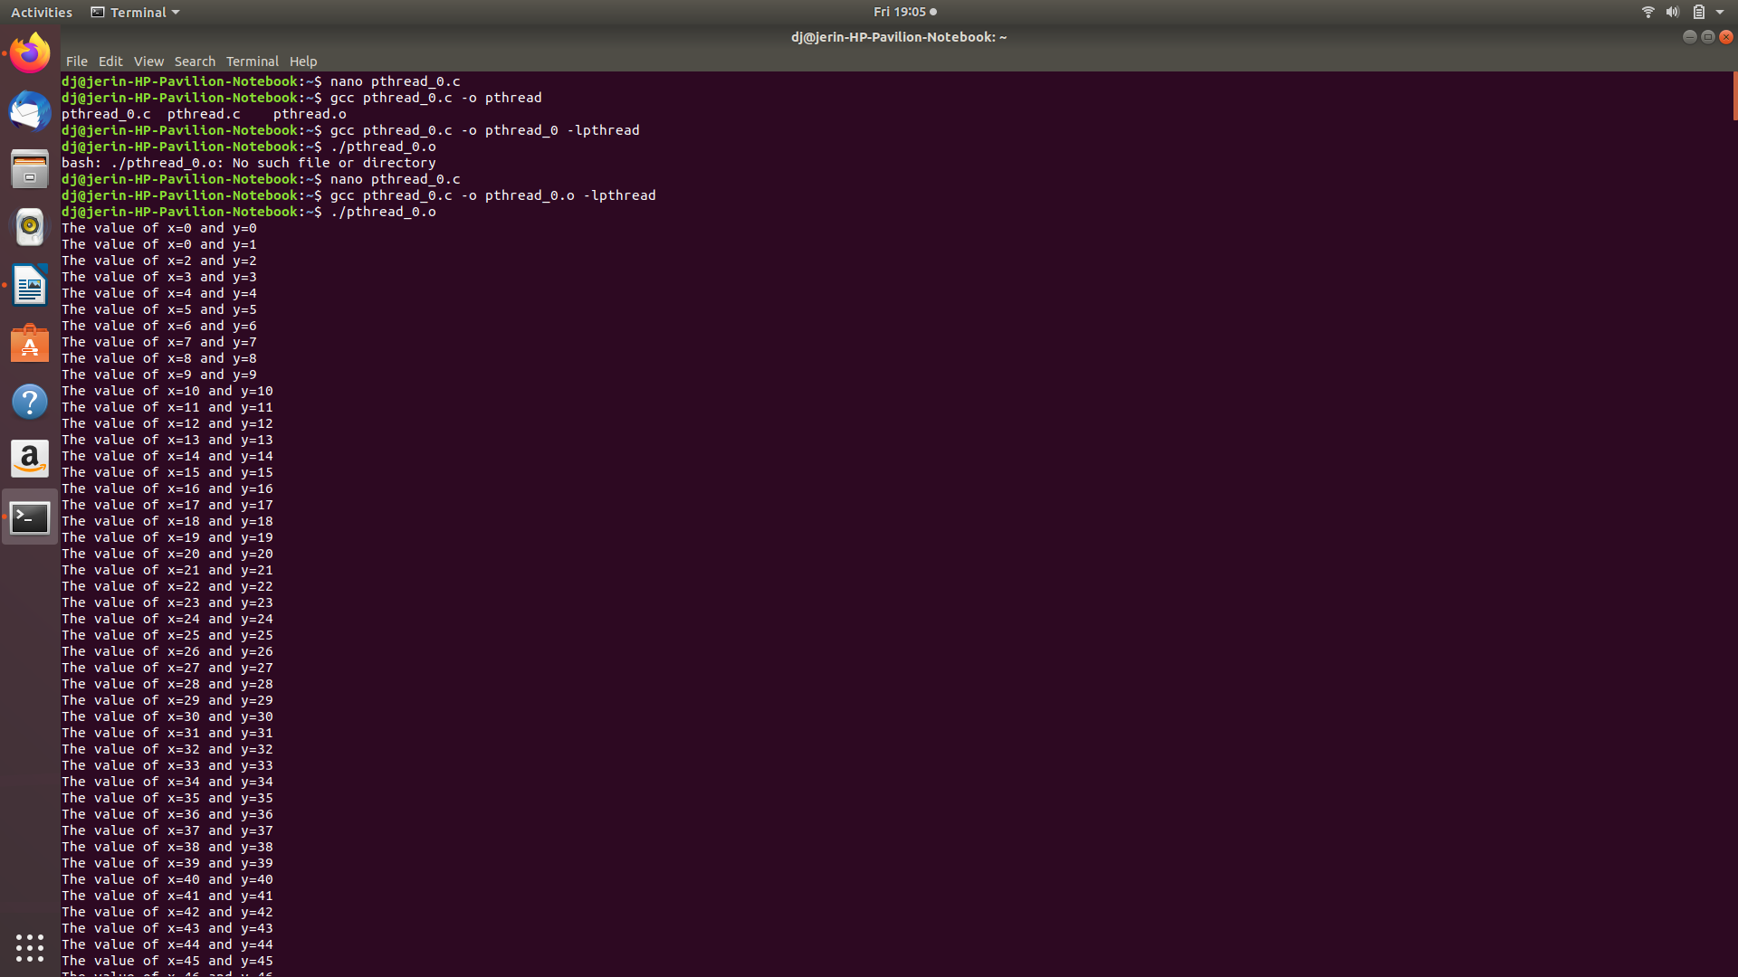

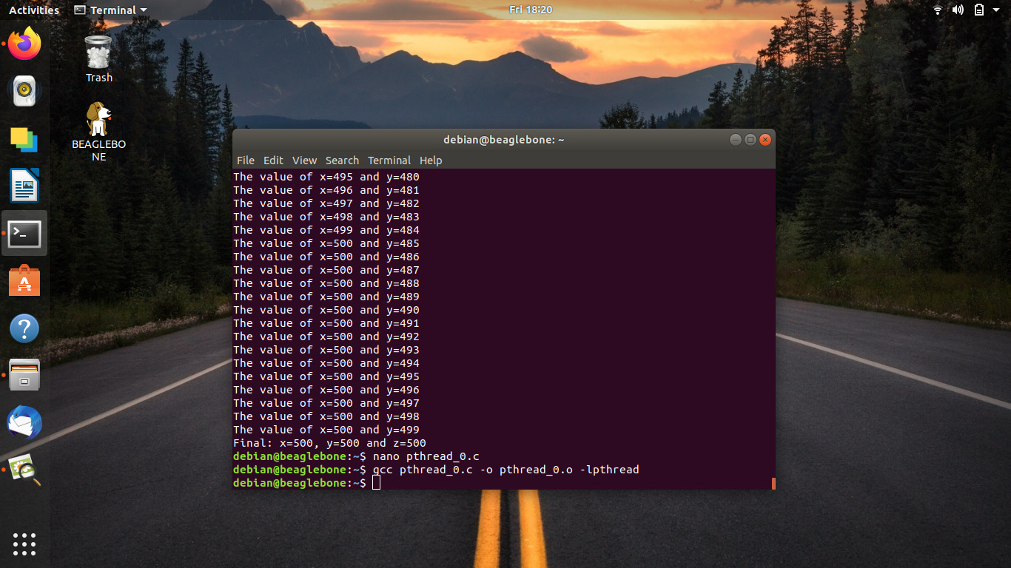

Q2. Guessing Game on using pthreads;

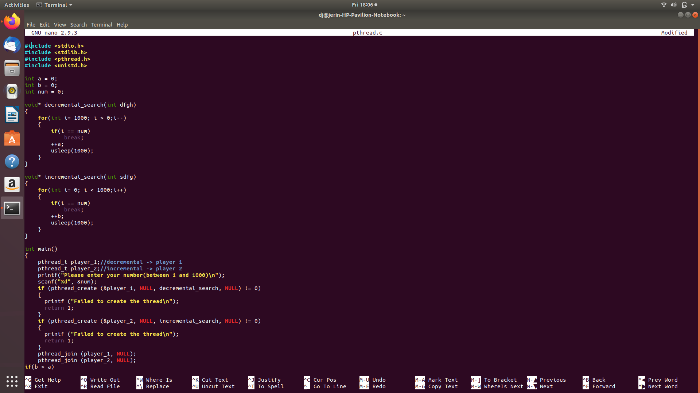
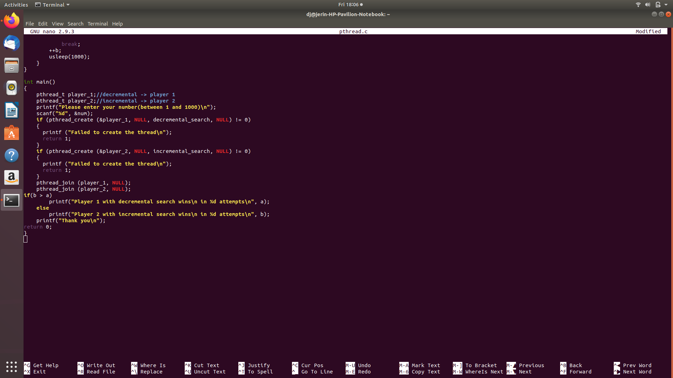

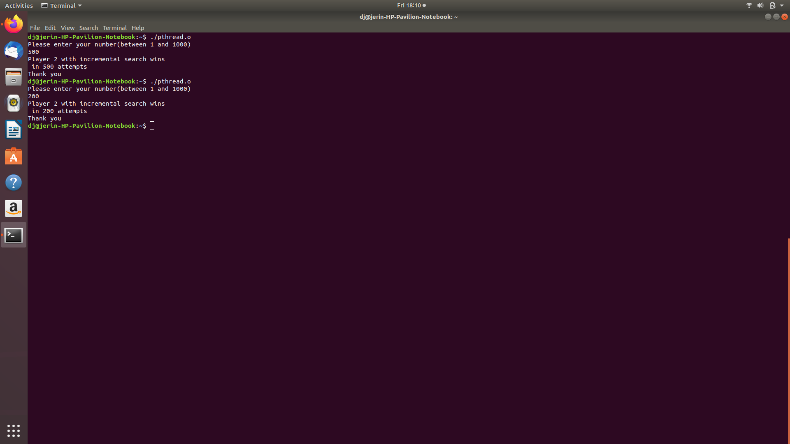

#include <stdio.h>
#include <stdlib.h>
#include <pthread.h>
#include <unistd.h>
int a = 0;
int b = 0;
int num = 0;
void* decremental_search(int dfgh)
{
for(int i= 1000; i > 0;i--)
{
if(i == num)
break;
++a;
usleep(1000);
}
}
void* incremental_search(int sdfg)
{
for(int i= 0; i < 1000;i++)
{
if(i == num)
break;
++b;
usleep(1000);
}
}
int main()
{
pthread_t player_1;//decremental -> player 1
pthread_t player_2;//incremental -> player 2
printf("Please enter your number(between 1 and 1000)\n");
scanf("%d", &num);
if (pthread_create (&player_1, NULL, decremental_search, NULL) != 0)
{
printf ("Failed to create the thread\n");
return 1;
}
if (pthread_create (&player_2, NULL, incremental_search, NULL) != 0)
{
printf ("Failed to create the thread\n");
return 1;
}
pthread_join (player_1, NULL);
pthread_join (player_2, NULL);
if(b > a)
printf("Player 1 with decremental search wins\n in %d attempts\n", a);
else
printf("Player 2 with incremental search wins\n in %d attempts\n", b);
printf("Thank you\n");
return 0;
}

